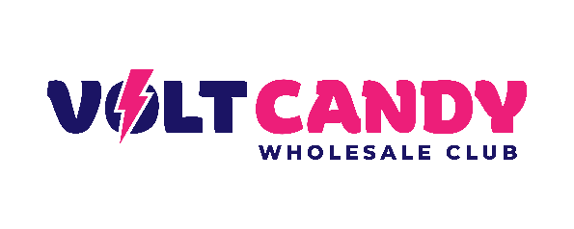
URGENT: PrimeZen Black 6000 RECALL

Ibrahim E.
298 E Monterey Ave
Pomona CA 91767
Date: 02/17/2023

Dear Consumer:

This is to inform you of a product recall involving:

PrimeZen Black 6000 lot numbers [NPINPB 1003] and expiration dates 08/16/2025, UPC Code: 728175521891

See enclosed product label.

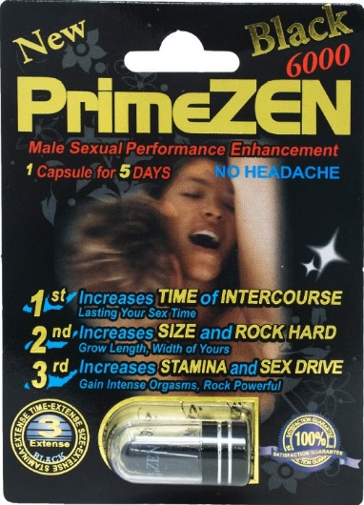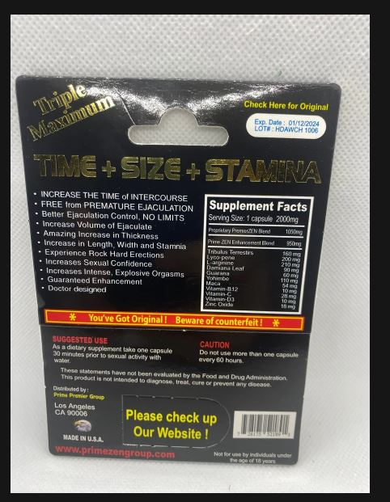

Volt Candy is voluntarily recalling one lot of PrimeZen Black 6000, 2000 mg capsule, to the consumer level. FDA analysis has found PrimeZen Black 6000 capsules to be tainted with sildenafil & tadalafil. Sildenafil and tadalafil are phosphodiesterase (PDE-5) inhibitors found in FDA-approved products for the treatment of male erectile dysfunction. The presence of sildenafil, tadalafil in PrimeZen Black 6000 capsules renders them unapproved drugs for which safety and efficacy have not been established and, therefore, subject to recall.

Risk Statement: PrimeZen Black 6000 capsules containing sildenafil and tadalafil may interact with nitrates found in some prescription drugs (such as nitroglycerin) and may cause a significant drop in blood pressure that may be life threatening. People with diabetes, high blood pressure, high cholesterol, or heart disease often take nitrates. Among the adult male population who are most likely to use these products, adult males who use nitrates for cardiac conditions are most at risk from these products. Volt Candy has not received reports of state adverse events or injuries to date.
We began shipping this product on January of 2022.
Immediately examine your inventory and quarantine product subject to recall. In addition, if you may have further distributed this product, please identify your customers and notify them at once of this product recall. Your notification to your customers may be enhanced by including a copy of this recall notification letter, Volt Candy is notifying their online customers by email and is arranging for return of all recalled products. Consumers or those with product in their possession should stop using and return the affected product PrimeZen Black 6000, lot number [NPINPB 1003] Expiration date 08/16/2025 to this address:
Volt Candy
324 S. Diamond Bar Blvd
#212
Diamond Bar, CA 91765
Consumers with questions regarding this recall can contact Volt Candy by e-mail info@voltcandy.com on weekdays between 9am-5pm PST. Consumers should contact their physician or healthcare provider if they have experienced any problems that may be related to taking or using this drug product.This recall should be carried out to the consumer level. Your assistance is appreciated and necessary to prevent <i.e. consumer illness or patient harm.
Please complete and return the enclosed response form with your name, address and phone number at the bottom of the page as soon as possible via email at info@voltcandy.com.

If you have any questions, call Volt Candy @ 1-855-215-3534.

This recall is being made with the knowledge of the Food and Drug Administration.

Ibrahim E
CEO
Enclosures:

